PSHE Long Term Plan Whole school

2-3

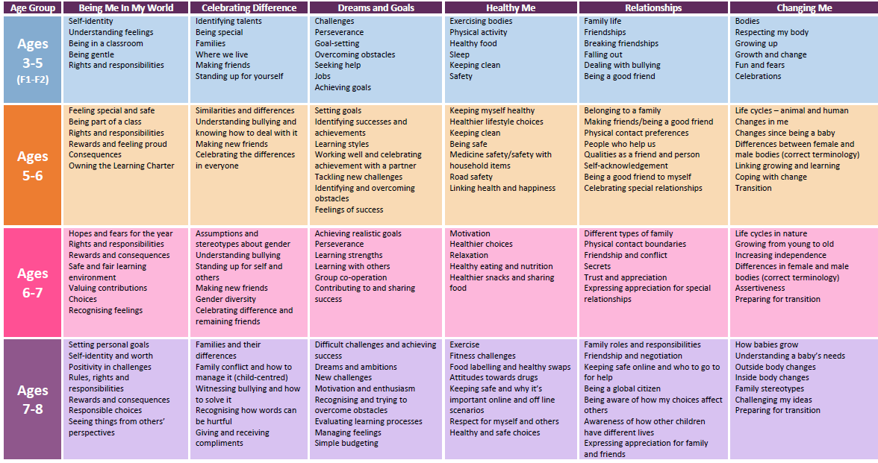 **Year 3**